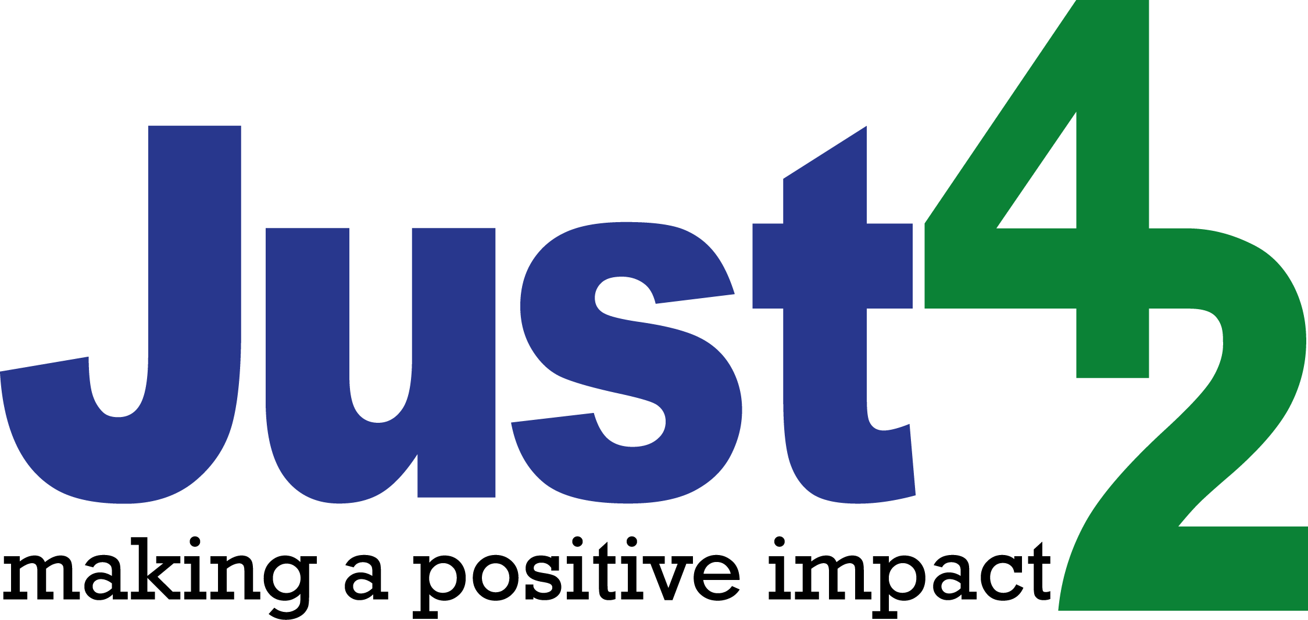

Session Youth Worker - Rural Clubs - Person Specification

Qualifications

- Evidence of basic literacy & numeracy skills (GCSE) Essential
- Satisfactory DBS (Disclosure and barring service) Essential
- Full driving licence Desirable
- Youth work training or qualifications Desirable
- Level 2 Food Hygiene Desirable
- First Aid training Desirable

Experience

- Previous experience of youth work in a club setting Desirable

Knowledge

- An understanding of young people’s development Essential
- An understanding of how young people learn Essential
- An understanding of issues facing young people today Essential
- An understanding of rural communities Desirable
- An understanding of SEND young people Desirable

Skills

- A team player Essential
- An ability to help young people learn and develop Essential
- An ability to build & maintain appropriate purposeful relationships
with young people Essential
- Good communication and organisational skills Desirable
- An ability to work with SEND young people when required Desirable

Attitudes

- A willingness to continue to learn and develop Essential
- A commitment to equal opportunities and empowerment Essential
- A desire to demonstrate God’s love and care for young people Desirable

We will arrange a DBS, First Aid and Food Hygiene training if needed.

